Student worksheet

4.1 Synthesis and decomposition reactions can be represented by equations

Pages 90–91

Synthesis and decomposition reactions

1 Why does classifying compounds into groups make them easier to name and identify?

|  |
| --- |
|  |
|  |
|  |

2 What is the law of conservation of mass?

|  |
| --- |
|  |
|  |

3 With regard to chemical reactions, explain the following.

a Synthesis reaction

|  |
| --- |
|  |
|  |

b Decomposition reaction

|  |
| --- |
|  |
|  |

c Electrolytic decomposition

|  |
| --- |
|  |
|  |

d Thermal decomposition

|  |
| --- |
|  |
|  |

e Hydrolysis reaction

|  |
| --- |
|  |

4 Predict the products of the following chemical reactions, balance the chemical equation, and identify the reaction as synthesis or decomposition.

a Na(s) + Cl2(g) → .

b H2O(l) → .

c Mg(s) + O2(g) → .

d HCl(aq) + Mg(s) → .

e N2(g) + H2(g) → .

f Na(s) + O2(g) → .

g CuSO4.5H2O(s) → .

Extend your understanding

Conduct some research on the process of electroplating and answer the following questions (also using your knowledge of electrolysis).

5 How is electroplating used in production and manufacturing?

|  |
| --- |
|  |
|  |

6 Explain how electroplating is used in the following industries.

a Food industry

|  |
| --- |
|  |
|  |

b Car-manufacturing industry

|  |
| --- |
|  |
|  |

c Jewellery-making industry

|  |
| --- |
|  |
|  |

7 What would happen to some metals if they did not undergo electroplating?

|  |
| --- |
|  |

8 Is electroplating necessary for all metals? Explain your answer.

|  |
| --- |
|  |
|  |
|  |

Student worksheet

4.2 Acid reactions depend on strength and concentration

Pages 92–93

Acid reactions

1 What is an acid?

|  |
| --- |
|  |
|  |

2 What are the properties of acids?

|  |
| --- |
|  |
|  |

3 What do all acids have in common?

|  |
| --- |
|  |
|  |

4 What is a base?

|  |
| --- |
|  |
|  |

5 What are the properties of bases?

|  |
| --- |
|  |
|  |

6 What do all bases have in common?

|  |
| --- |
|  |
|  |

7 What are the products of any acid–base reaction?

|  |
| --- |
|  |

8 What is this type of reaction called?

|  |
| --- |
|  |

9 Why is it called this?

|  |
| --- |
|  |
|  |

10 What are the products of the following metal reactions?

a acid + base

|  |
| --- |
|  |

b acid + metal

|  |
| --- |
|  |

c acid + metal oxide

|  |
| --- |
|  |

d acid + metal carbonate

|  |
| --- |
|  |

11 Write balanced chemical equations, including states, for the following reactions.

a H2SO4(aq) + NaOH(aq) → .

b HNO3(aq) + Na(s) → .

c HCl(aq) + MgO(s) → .

d HF(aq) + Na2CO3(s) → .

12 Identify the following images as either a dilute strong acid, a concentrated strong acid, a dilute weak acid, or a concentrated weak acid.

|  |  |  |  |
| --- | --- | --- | --- |
|  |  |  |  |
|  |  |  |  |

Extend your understanding

13 Research acids and bases that are located within your body and answer the following questions.

a What is the main acid found within your stomach?

|  |
| --- |
|  |

b Is this a strong or weak acid?

|  |
| --- |
|  |

c What happens to this acid when it leaves the stomach and enters the small intestine?

|  |
| --- |
|  |
|  |

d Why does the acid have to be treated before it enters the small intestine?

|  |
| --- |
|  |
|  |

e What happens if your body produces excessive acid within your stomach?

|  |
| --- |
|  |
|  |

Student worksheet

4.3 The solubility rules predict the formation of precipitates

Pages 94–95

Precipitation reactions

1 What do the following terms mean?

a Soluble

|  |
| --- |
|  |
|  |

b Insoluble

|  |
| --- |
|  |
|  |

c Precipitate

|  |
| --- |
|  |
|  |

d Spectator ion

|  |
| --- |
|  |
|  |

2 For each of the following molecules, determine whether it is soluble or insoluble, and assign a state to each.

a AgNO3

|  |
| --- |
|  |

b NH4Cl

|  |
| --- |
|  |

c PbCl2

|  |
| --- |
|  |

d Cu(OH)2

|  |
| --- |
|  |

e Fe(OH)3

|  |
| --- |
|  |

f NaNO3

|  |
| --- |
|  |

g AgCl

|  |
| --- |
|  |

h Na2CO3

|  |
| --- |
|  |

i Na3PO4

|  |
| --- |
|  |

j (NH4)2CO3

|  |
| --- |
|  |

3 Write a balanced chemical equation for the following precipitation reactions, including states.

a Pb2NO3 + NaCl →

|  |
| --- |
|  |

b Na2CO3 + MgCl2 →

|  |
| --- |
|  |

c NaOH + MgBr2 →

|  |
| --- |
|  |

4 Write a balanced chemical equation for the following precipitation reactions, including states.

a silver nitrate and barium chloride

|  |
| --- |
|  |

b sodium bromide and lead (II) nitrate

|  |
| --- |
|  |

c mercury (II) nitrate and sodium iodide

|  |
| --- |
|  |

d sodium phosphate and calcium chloride

|  |
| --- |
|  |

e magnesium sulfide and copper (II) nitrate

|  |
| --- |
|  |

f lithium sulfate and barium chloride

|  |
| --- |
|  |

Extend your understanding

5 A chemist wishes to determine the amount of salt (NaCl) in a packet of chicken soup. She starts by dissolving the soup in hot water, allowing it to cool and then filtering the solid particles out of the solution.

a Suggest a method the chemist could incorporate that would allow her to determine how much salt is in the soup. You must outline the chemicals you would use and the procedure you would follow.

|  |
| --- |
|  |
|  |
|  |
|  |
|  |
|  |

b Identify two errors that may be involved with this experiment. They could be in the method you have outlined above or in the initial procedure that the chemist used. What would you do to minimise their effect on your results?

|  |
| --- |
|  |
|  |
|  |
|  |
|  |
|  |

Student worksheet

4.4 Combustion reactions between hydrocarbons and oxygen produce carbon dioxide, water and energy

Pages 96–97

Combustion reactions

1 Explain the following terms.

a Oxidation

|  |
| --- |
|  |

b Combustion

|  |
| --- |
|  |

c Limited oxygen

|  |
| --- |
|  |

d Carbon economy

|  |
| --- |
|  |
|  |

2 Provide an example for the following reactions (different from the examples in your student book).

a Oxidation reaction with metals

|  |
| --- |
|  |

b Oxidation reaction with non-metals

|  |
| --- |
|  |

3 Write a balanced chemical equation for the combustion of the following hydrocarbons.

a Methane

|  |
| --- |
|  |

b Ethane

|  |
| --- |
|  |

c Propane

|  |
| --- |
|  |

d Butane

|  |
| --- |
|  |

e Pentane

|  |
| --- |
|  |

f Hexane

|  |
| --- |
|  |

g Heptane

|  |
| --- |
|  |

h Octane

|  |
| --- |
|  |

4 How has the burning of fuels changed over time? Explain with reference to the different fuels that have been used.

|  |
| --- |
|  |
|  |
|  |
|  |

5 Fuels that are derived from plants are said to be ‘carbon neutral’. What does this term mean?

|  |
| --- |
|  |
|  |
|  |

Extend your understanding

6 Research fractional distillation. Use your knowledge and Figure 4.7 on page 97 of your student book to answer the following questions.

a What is fractional distillation?

|  |
| --- |
|  |
|  |
|  |

b What is crude oil made from and why is it called ‘crude’ oil?

|  |
| --- |
|  |
|  |
|  |

c In Figure 4.7 of your student book, what do you notice about the trend between temperature and the number of carbon atoms?

|  |
| --- |
|  |
|  |
|  |

d What can you conclude about the boiling points of hydrocarbons?

|  |
| --- |
|  |
|  |
|  |

e What happens to the residue?

|  |
| --- |
|  |
|  |

Student worksheet

4.5 Polymers are long chains of monomers

Pages 98–99

Polymers and polymerisation reactions

1 Explain the following terms.

a Monomer

|  |
| --- |
|  |
|  |

b Polymer

|  |
| --- |
|  |
|  |

c Covalent bond

|  |
| --- |
|  |
|  |

d Linear polymer

|  |
| --- |
|  |
|  |

e Cross-linked polymer

|  |
| --- |
|  |
|  |

2 Identify the following structures as linear or cross-linked polymers.

|  |  |
| --- | --- |
|  |  |
|  |  |
|  |  |
|  |  |

3 Identify the structures as thermoplastic or thermosetting polymers.

|  |  |
| --- | --- |
|  |  |
|  |  |
|  |  |
|  |  |

4 Name three thermoplastic polymers and three thermosetting polymers (different from those given in your student book).

|  |
| --- |
|  |
|  |
|  |
|  |

5 Draw the polymers that would result from the following monomers.

|  |  |
| --- | --- |
| Monomer | Polymer |
|  |  |
|  |  |
|  |  |

Extend your understanding

Biomolecules are polymers of more simple molecules. Research biological polymers and answer the following questions.

6 What is the common name for a carbohydrate?

|  |
| --- |
|  |

7 What is the monomer of this biomolecule? Include a diagram of the monomer.

|  |
| --- |
|  |

|  |
| --- |
|  |

8 What is the common name for lipids?

|  |
| --- |
|  |

9 What is the monomer of this biomolecule?

|  |
| --- |
|  |

10 What is a monomer of DNA called?

|  |
| --- |
|  |

11 What molecules is the monomer made up of?

|  |
| --- |
|  |

12 What monomer is a protein made of?

|  |
| --- |
|  |
|  |

13 How does DNA turn into a protein? Very briefly explain the process.

|  |
| --- |
|  |
|  |
|  |
|  |
|  |
|  |

Student worksheet

4.6 Temperature, concentration, surface area and stirring affect reaction rate

Pages 100–103

Factors affecting the rate of a chemical reaction

1 Explain the collision theory.

|  |
| --- |
|  |
|  |
|  |

2 What are the two requirements of collision theory that allow reactants to form products?

|  |
| --- |
|  |
|  |
|  |
|  |

3 For each of the following, explain which of the situations will result in a faster rate of chemical reaction and explain why.

a A mug of hot water and a mug of cold water dissolve a teaspoon of coffee.

|  |
| --- |
|  |
|  |
|  |

b A whole cube of sugar and a teaspoon of granulated sugar dissolve in a cup of room-temperature water.

|  |
| --- |
|  |
|  |
|  |

c A 2 g tablet of calcium dissolves in 2M HCl (concentrated) and 0.01M HCl (dilute).

|  |
| --- |
|  |
|  |
|  |

d Two teabags are placed in two cups of hot water. One cup of tea is stirred; one is not.

|  |
| --- |
|  |
|  |
|  |

Extend your understanding

Jack and Trinity devised different methods to dissolve a vitamin C tablet in 100 mL of water in a beaker. They both believed their method would dissolve the tablet the fastest and made a bet. To determine the winner of the bet, they decided to run the experiments to find out which method dissolved the tablet the fastest.

A control was run first – a whole tablet was dissolved in 100 mL of water at 20°C.

Jack dissolved his tablet in 100 mL of water after he had heated it to 40°C.

Trinity broke her tablet into four and then dissolved the pieces in 100 mL of water at 20°C.

4 What was Jack’s hypothesis?

|  |
| --- |
|  |
|  |
|  |
|  |

5 What is Trinity’s hypothesis?

|  |
| --- |
|  |
|  |
|  |
|  |

6 Why was a control used? What was its purpose?

|  |
| --- |
|  |
|  |
|  |
|  |

7 Using your knowledge of rates of chemical reactions, which method do you think will dissolve the tablet the fastest? Explain why.

|  |
| --- |
|  |
|  |
|  |
|  |

8 The results gained from the experiment are shown below. Use the grid provided to graph the results.

|  |  |  |  |
| --- | --- | --- | --- |
|  | Control | Jack | Trinity |
| Size of tablet | Whole tablet | Whole tablet | Tablet in four pieces |
| Temperature (°C) | 20 | 40 | 20 |
| Time to dissolve (s) | 50 | 40 | 35 |



9 Are the students able to compare their results? Explain your answer.

|  |
| --- |
|  |
|  |
|  |
|  |

10 Suggest improvements for Trinity and Jack to dissolve their tablets faster.

|  |
| --- |
|  |
|  |
|  |
|  |

Student worksheet

4.7 Catalysts increase the rate of a reaction

Pages 104–105

The effect of catalysts on the rate of a chemical reaction

1 State how catalysts work.

|  |
| --- |
|  |
|  |
|  |
|  |

2 What is the purpose of a catalyst?

|  |
| --- |
|  |

3 Using your knowledge of chemical reactions, explain how a catalyst can increase the rate of a chemical reaction.

|  |
| --- |
|  |
|  |

4 What agreement was made in the Montreal Protocol in 1987?

|  |
| --- |
|  |

5 Explain why this decision was so important for society.

|  |
| --- |
|  |
|  |
|  |

Extend your understanding

Pressure also affects the rate of a chemical reaction.

6 What types of chemical reactions would be affected by pressure?

|  |
| --- |
|  |

7 The diagram below shows gas particles in three different containers (with yellow weights holding the lids on the containers). Which of the containers has the highest concentration? Explain why.

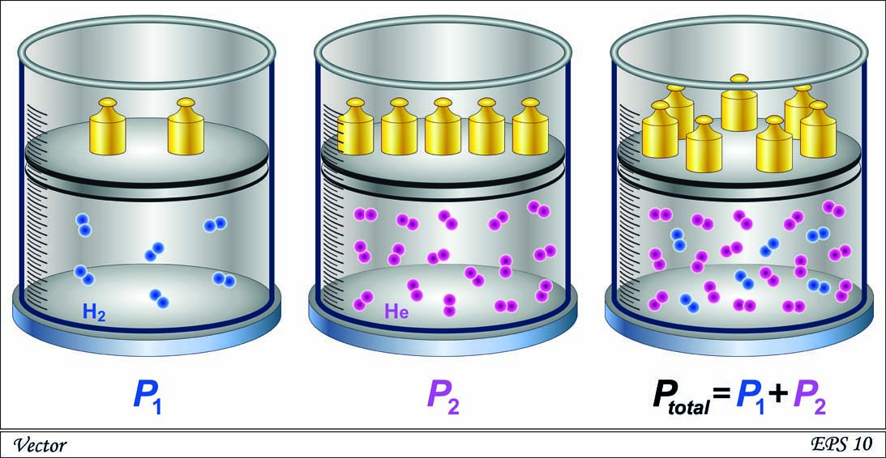

|  |
| --- |
|  |
|  |

8 Why are there more weights holding the lid on the right container?

|  |
| --- |
|  |
|  |

9 Which of the above containers would have a higher pressure?

|  |
| --- |
|  |

10 Explain the relationship between the concentration of gases and pressure.

|  |
| --- |
|  |
|  |

11 A half-empty bottle of water is left in the sun on a warm day. What happens to the bottle? Explain your answer.

|  |
| --- |
|  |
|  |
|  |

Student worksheet

4.8 Green chemistry reduces the impact of chemicals on the environment

Pages 106–107

Green chemistry

1 What is green chemistry?

|  |
| --- |
|  |
|  |

2 In the space provided, design a poster that promotes green chemistry to the public. Ensure you include what people should and should not do (or purchase) to follow the principles of green chemistry.

|  |
| --- |
|  |

Extend your understanding

3 Research the 12 principles of green chemistry. Complete the table below by stating each principle and explaining how each can be used to reduce waste in the chemical industry.

|  |  |  |
| --- | --- | --- |
|  | Principle | How it can be used to reduce waste |
| 1 |  |  |
| 2 |  |  |
| 3 |  |  |
| 4 |  |  |
| 5 |  |  |
| 6 |  |  |
| 7 |  |  |
| 8 |  |  |
| 9 |  |  |
| 10 |  |  |
| 11 |  |  |
| 12 |  |  |